
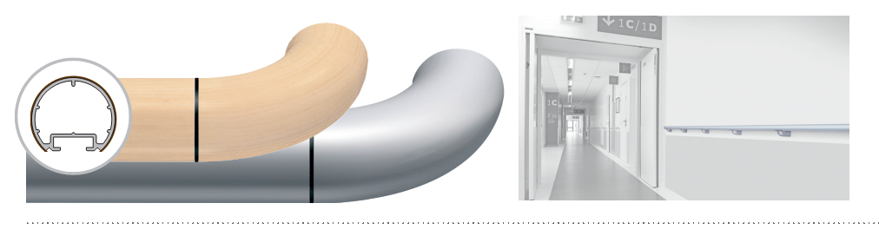

SPECIFICATION

ESCORT DECOWOOD & ANODISED
ROUND HANDRAIL – DIAMETER 40 MM

- Description: round wood effect handrail (Escort – Decowood as manufactured by SPM) or satin silver anodised aluminium (Escort – Anodised as manufactured by SPM) with a diameter of 40 mm and an overall projection and height of 80 mm. It consists of a 1.5 mm thick continuous aluminium profile and a matching closer underneath. The section comprises a groove into which brackets and matching closer slide and lock. Wall fixing is by 40 mm deep satin silver anodized aluminium brackets with 2-point self-locking: curved and perforated (80 mm wide), curved and full (60 mm wide) or bugled (55 mm wide).Various smooth and antibacterial PVC accessories (round or flat endcaps, external and internal 90° angle pieces or made-to-measure from 90 to 165°, wall returns), supplied with bactericidal joints, are available in wood effect or anodised look or chromium look to finish the handrail assembly and are sleeved into the profile. All technical solutions are available to ensure continuity around corners (90° or made-to-measure), in staircases (slope link or 3-way “universal joint” rotation angle –Rapid’Angle® as manufactured by SPM-), across service ducts (quick removable assembly wedge or articulated link –Rapid’Access® as manufactured by SPM-) and around curved sections (pre-curved in the factory).
- Environment: no heavy metals and no substance potentially subjected to any REACH restriction are used in its manufacture, nor PBT/BPA. The calcium-zinc thermal stabilisation process is used. The emission level of volatile substance in inside air has been tested according to ISO 16000-6 and is very low (A+) according to the French regulation (23 March 2011 nr 2011-321 Decree and 19 April 2011Order). 100% of the product are recyclable.
- Colour: selected by architects from manufacturer’s standard range.
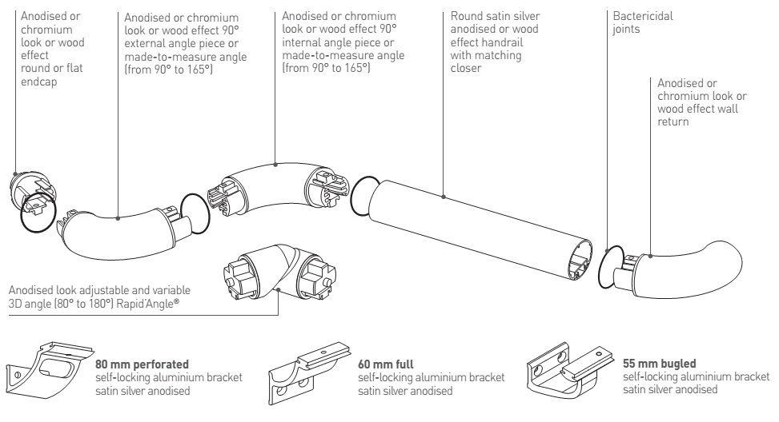

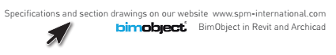
Installation method: upper edge of section 0.90 m max. above floor level. Fixes to 2-point self-locking aluminium brackets screwed to the wall at 1.20 m centres (0.80 m centres in heavy traffic corridors and on light partitions like plasterboard). Wall returns, endcaps and angles to be fixed with 2.5 mm Allen clamping screws

